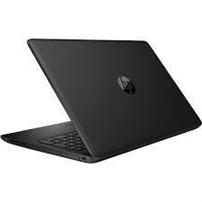

HP 15-DA2007

* Intel Core I5-10210U
* 1.6 GHz, Up To 4.2 GHz
* 4GB DDR4, 1TB HDD
* 15.6 HD DOS
* **Rs.107,900**